**SULEYMAN DEMIREL UNIVERSITY**

**ENGINEERING FACULTY**

**INF 305 - Database Management Systems 2**

**Project documentation**

**Checked by: Assem Talasbek**

**Made by: Nurbakyt Akhmetshaiykov**

**Kaskelen 2021**

**Structure:**

* Abstract
* Introduction
* Aim and objectives of research
* Background Review
* Methods and Materials
* Data and Results
* Discussion
* Conclusion
* References
* ***Abstract***

It is generally acknowledged that football industry injured after pandemia of coronavirus, consequently only fans of football can help to recover that industry. So this project is about footballing web- application to elevate the fan experience.

***Key Terms:*** web-app, match statistics, Oracle Database

* ***Introduction***

The world football industry is one of the largest global markets in the world, with European football alone being valued at around £21.9 billion [1], just showing the huge power that the sport has. The major driving force in this market being the fans, and the ever-growing popularity of the world’s most watched sport, with approximately 4 Billion fans worldwide [2].

The ‘*problem area*’ this project will be focused on is fan involvement in the sport and ways of improving fans experience of following a team and attending football matches.

The solution proposed by this project to this area will be the making of a web application to allow users to track matches they have attended by registering them when they attend, the web app will then show the user statistics about the matches they have seen personalised for them. Some example statistics would be, total goals seen and how many of those goals were scored by the team they support etc. This will enhance the fan experience as it gives fans a way of analysing the matches they have attended, in a way that is personalised to them, making them feel more involved in the sport. This can be used by fans to see the effect they may have on their team whether it be lucky or unlucky, or simply as a way of recording all the matches they have attended in a collected space. The frontend of the web app will display information to the user and allow them to interact with it, this will be coded in HTML, CSS, PHP and JavaScript where appropriate. The Backend of the application will be a database with all relevant data that needs to be displayed, this will be coded in Oracle PL/SQL.

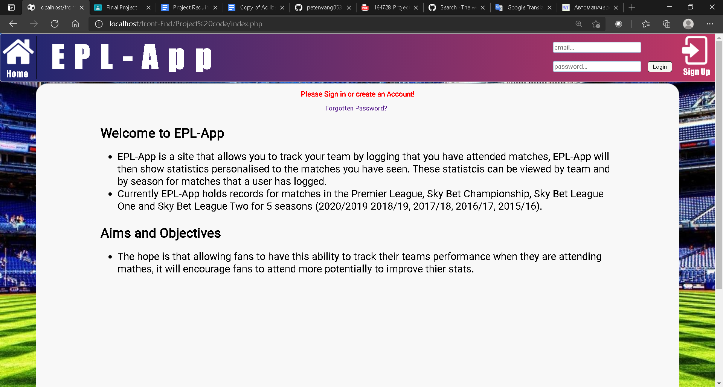

Figure 1. Home page (Not logged in)

* ***Aim and objectives of research***

This section will outline the main aims and objectives for the project:

• Create a web app which enhances the fan experience of following a team and attending matches.

• Provide a service for fans to see statistics personalised to matches they have attended in creative and graphical ways.

• Allow fans to analyse their stats on a team by team basis and delve deeper by analysing statistics for individual matches.

• Create a space for fans to record all matches they have attended, so they do not have to remember them themselves.

• Allow fans to see the effect they have when attending matches, e.g. whether they have a positive or negative impact on their team.

• Create a web app which is easy to use and understand for the target demographic with little explanation.

• Create a secure service that users can trust with their information.

The hope is if all these aims are met a service will have been created that will encourage more fans to attend matches with the incentive of improving their stats or through friendly competition between friends. This will have a particularly positive effect on smaller teams who rely heavily on fan attendance for finances.

* ***Background review***

In order to build the web application some background research had to be done to find what websites and products existed with a similar premise. The websites and apps including, Futbology App [3] and the Sky Bet EFL Rewards App [4] are a few examples of what is available to football fans when looking for content online. The vast majority of what is available tends to have a focus on giving its users a more statistical analysis of games and giving build up and reports for matches, the market is very saturated with sites of this kind. This is good for users as it gives a way for fans to absorb football content outside of matchdays and allows for creative debate and discussion where people have facts and figures to back up what they are saying.

The web application proposed by this project however does not fall into this market, there are a few specific sites/apps that do have a similar purpose, some good examples are the Futbology App and the Sky Bet EFL Rewards App. Futbology is an app available on IOS and Android which allows users to log that they have been to matches which are then stored for the user. The app differs from the one proposed in this project however as there is little to no statistics available to the user, the app is heavily focused on keeping track of what football grounds have been visited and some of the limited stats available include number of grounds visited and most visited ground. This differs from what has been proposed by this project because the web application proposed aims to provide more detailed stats of the matches to users rather than just a record of what grounds have been visited. Something Futbology does well is allowing users to suggest their own match if the match they wish to log is not available, this makes it easy for users who follow teams who are not well known to use the app too. The leader board section for each club is also a good way to promote competition between fans.

The Sky Bet EFL Rewards app is also an app with a similar premise, it is available on IOS and Android and allows users to ‘check-in’ to EFL matches (Championship to League two and cups). The users can select that they are at the stadium which is verified using location services and receive the chance to win rewards from Sky, or they can select that they are at home and will not be eligible for rewards. There are achievements that can be completed by going to matches, but there is no other purpose of the app and no statistics are available to users. Although these apps have a similar premise to the one proposed they do not have the same functionality or pose the same solution to the problem, this means that there is a gap in the market for the web app proposed as there is not an app like it available or not a popular one. This shows that this web app would be something new to the target audience which could help enhance their user experience.

* ***Methods and Materials***

Web- app mostly written in PHP, this was chosen as it is a simple and easy to use language with built in database connection modules. This allowed a simple way to connect the front and backend. I used Oracle OCI8 library and methods provided by that library to connect with front end. PHP also is an established language, so help was readily available online when needed during implementation. JavaScript was then used for displaying graphs on the statistics page as online code libraries could be sourced to create different interactive graphs. The project also wanted to use a variety of technologies hence the mix of languages, no framework was used to create the system as my intention and goal was to create the system from scratch.

* ***Data and Results***

The project required data from football matches in order to complete its purpose, this data was used to fill the database for the backend of the web app. All the data for this project was sourced from ‘football-data.co.uk’ [5], this site provides data in the form of CSV (comma separated values) files containing statistics for each match for a full season. This file format was ideal for the project as CSV files can be imported easily into tables in a database. The site provides data for football leagues in England, the sample chosen for this project is data from England’s top four leagues (Premier League, Championship, League One and League Two) for 5 seasons (19/20, 18/19, 17/18, 16/17, 15/16). This sample was chosen as it gives plenty of data for users to interact with on the site but is still a manageable amount. Going beneath data for League Two, i.e. North and South Divisions, there is less information available for each match, for the purpose of this project all the data must be in the same format otherwise errors may occur on the data retrieval from the database. This site provides the data free of charge and allows it to be edited before use, this is important as some data in the CSV files is irrelevant for the purpose of this project. For example, the betting odds for each match, which were removed before being inserted into the database and team names were replaced with a number identifier. This data sample had the potential to be expanded upon as the project unfolded if deemed necessary.

Almost 12,000 match records was inserted into database.

***Data about match information:***

MatchId ***-*** a unique identifier of the match;

HomeTeam - number id of home team;

AwayTeam- number id of away team;

M_Date- date of the match;

FTHG - number of goals of home team in full time;

FTAG - number of goals of away team in full time;

M_RESULT - char of  H, A, D values; H- if home team wins, A- if away team wins, D- if draw in full time;

HTHG - number of goals of home team in half time;

HTAG - number of goals of away team in half time;

HALFRESULT - char of  H, A, D value; H-if home team wins A- if away team wins, D- if draw in half time;

HSHOT- number of all home team shots;

ASHOT- number of all away team shots;

HSHOTTAR - number of shots on target of home team;

ASHOTTAR - number of shots on target of away team;

HFOULS - number of fouls of home team;

AFOULS - number of fouls of away team;

HCORNERS - number of corners of home team;

ACORNERS - number of corners of away team;

HYELLOW - number of yellow cards of home team;

AYELLOW - number of yellow cards of away team;

HRED - number of red cards of home team;

ARED - number of re cards of away team;

***Data about teams:***

TEAMID - a unique identifier of the team;

TEAMNAME - name of the team;

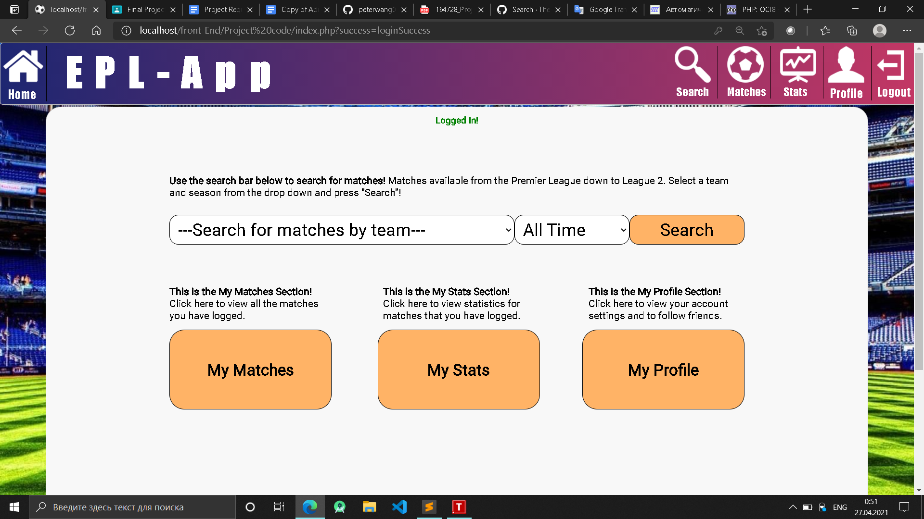

*Figure 2. Main page to Search Match.*

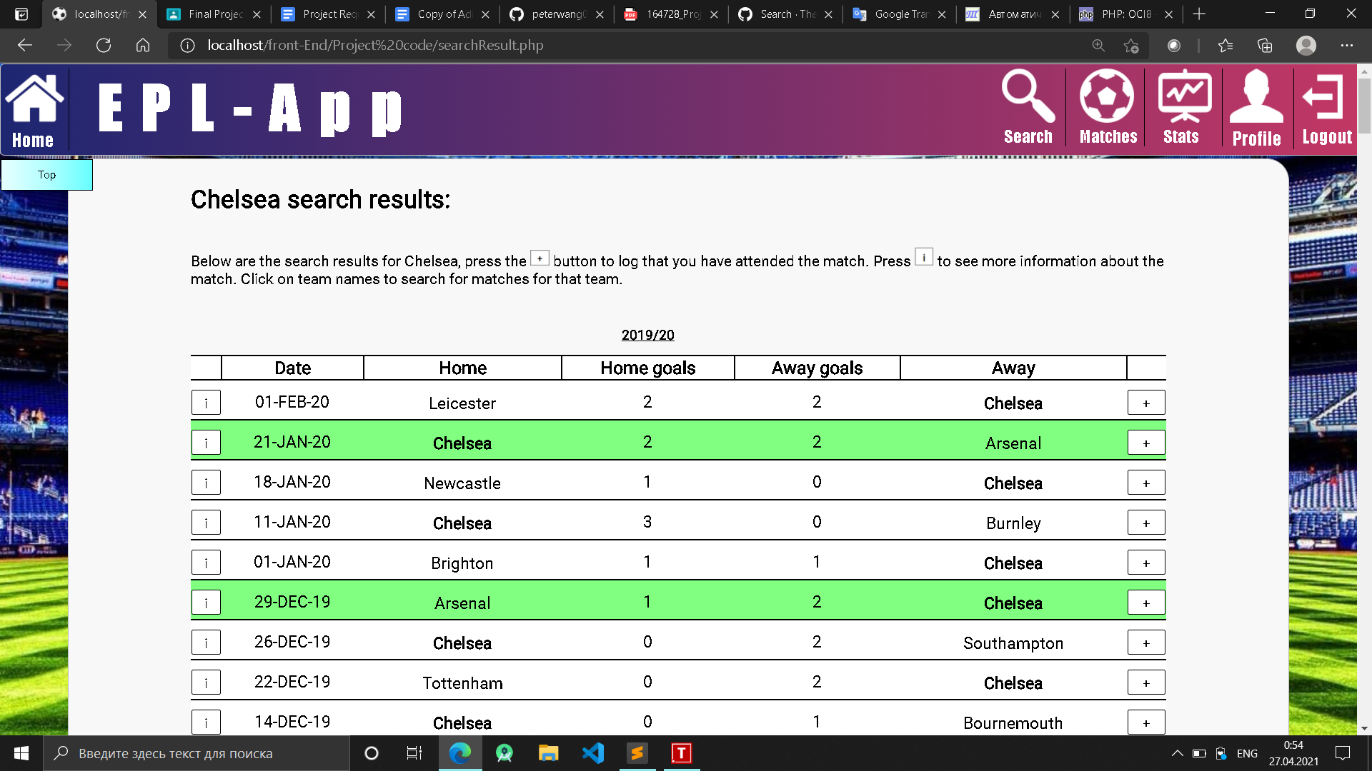

*Figure 3. Search results for specific team.*

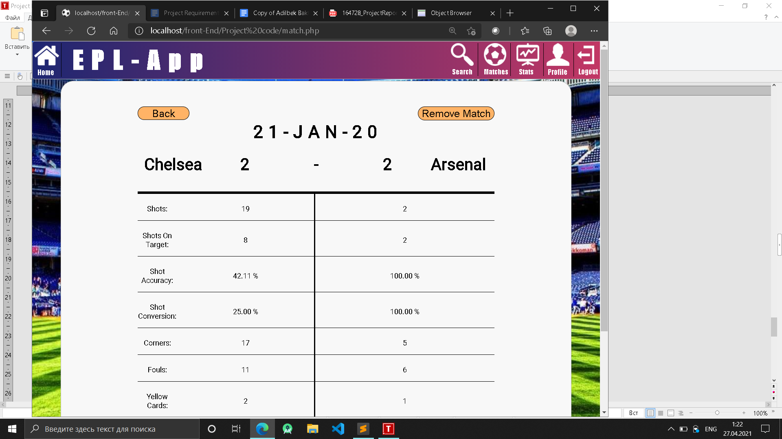

*Figure 4. Match info.*

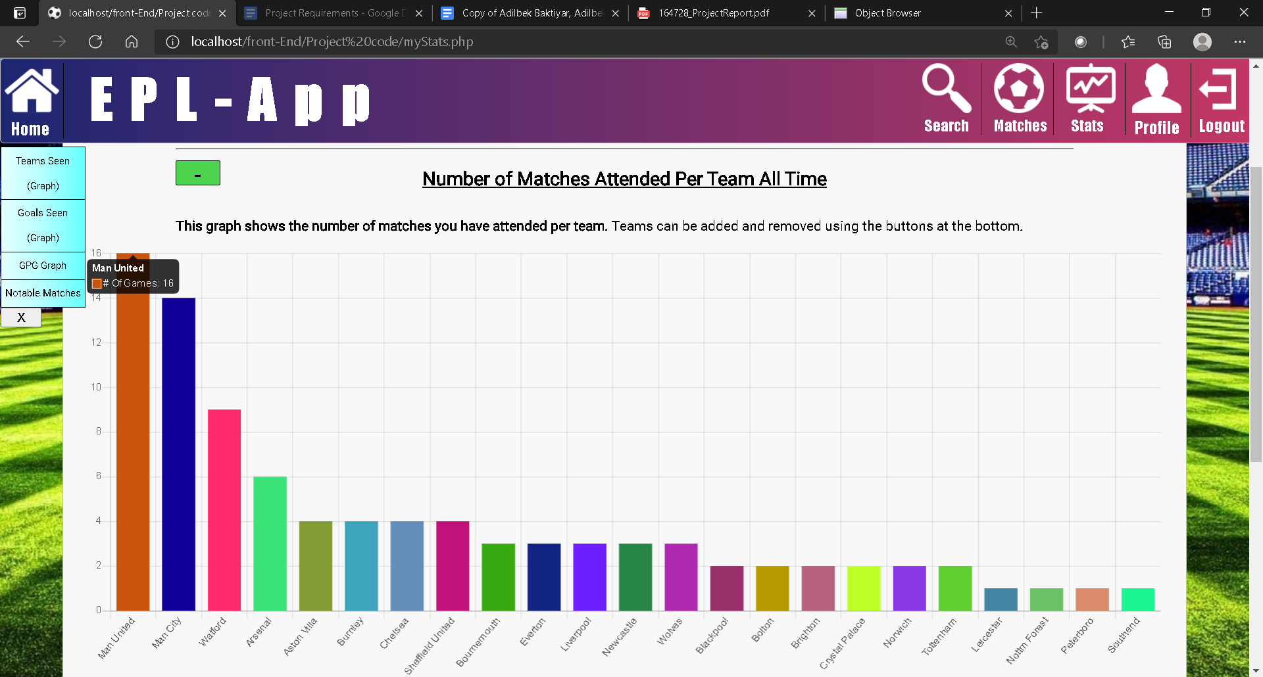

*Figure 5. Stats page Graph example(1)*

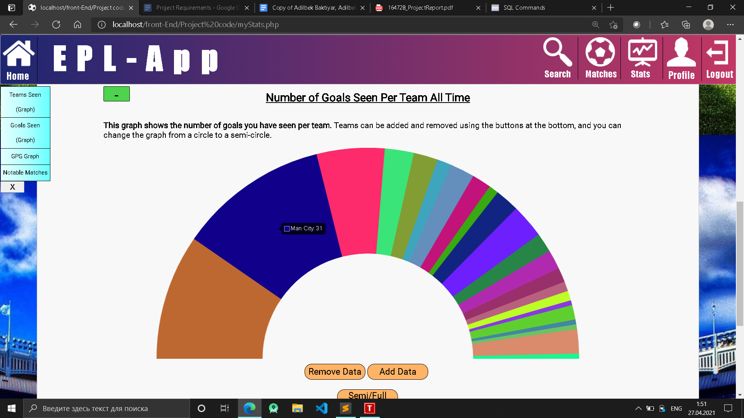

*Figure 6. Stats page Graph example(2)*

* ***Discussion***

I propose for my project that I will make a web application that will allow users to log that they have been to football matches, the application will then display stats relating to matches a user has seen e.g. goals seen, win % ect. I tried to display these stats in an appealing way to users, and tried to make a wide variety of stats available. Users will need to make an account to access the application, as their matches that they have seen will need to be saved in a database to access them. The matches available for the application will initially be the top four leagues in England (Premier League - League two) for the past 5 seasons (19/20 – 15/16).

* ***Conclusion***

I made this database and web application because I have a lot of interest in football, and I would like to enhance the spectator experience of going to football matches. I feel this app would do this as it can help users analyse the games they have seen and potentially even compete against friends to who has the ‘best’ stats.

* ***References***

[1] Deloitte United Kingdom. European football market worth a record €25.5 billion (£21.9bn) as Premier League leads the way in new era of financial stability. Available at: <https://www2.deloitte.com/uk/en/pages/press-releases/articles/annual-review-of-football-finance-2018.html> .

[2] Sawe, B. The Most Popular Sports in the World. [online] WorldAtlas. Available at: [The Most Popular Sports In The World - WorldAtlas](https://www.worldatlas.com/articles/what-are-the-most-popular-sports-in-the-world.html).

[3] Play.google.com. Available at: [Futbology – Apps on Google Play](https://play.google.com/store/apps/details?id=com.kepermat.groundhopper&hl=en_GB).

[4] App Store. Sky Bet EFL Rewards. Available at: https://apps.apple.com/gb/app/sky-bet-efl?rewards/id1470928154 .

[5] Football-data.co.uk. England Football Results Betting Odds | Premiership Results & Betting Odds. Available at: [England Football Results Betting Odds | Premiership Results & Betting Odds (football-data.co.uk)](https://www.football-data.co.uk/englandm.php)